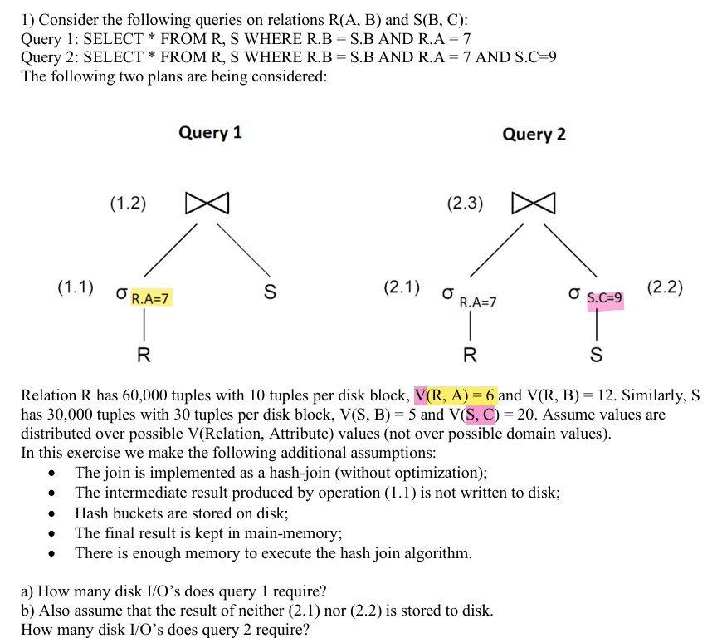

Explanation of the Question and Solution in the Provided Images
The question focuses on evaluating the disk I/O cost of two different query execution plans using a hash join algorithm. The queries involve two relations:
- Relation R(A, B) with 60,000 tuples, stored in blocks with 10 tuples per block.
- Relation S(B, C) with 30,000 tuples, stored in blocks with 30 tuples per block.
The two query plans differ in the order of applying selections and joins.

Concept Covered: Hash Join Algorithm
The hash join is a two-phase algorithm used to efficiently join large relations when there isn’t an appropriate index. It consists of:
- Partitioning Phase:
  - The smaller relation is read into memory, hashed into different buckets, and stored on disk.
  - The larger relation is read and also partitioned using the same hash function.
- Probing Phase:
  - The smaller relation’s partitions are read from disk and used to probe the corresponding partitions of the larger relation.
  - The matching tuples are joined in-memory.
This method reduces the number of disk accesses compared to nested loop joins.

Understanding the Queries and Execution Plans

Query 1:
SELECT * FROM R, S WHERE R.B = S.B AND R.A = 7;
- The selection R.A = 7 is applied first, reducing the number of tuples in R.
- Then, a hash join is performed between the filtered R and S on R.B = S.B.

Query 2:
SELECT * FROM R, S WHERE R.B = S.B AND R.A = 7 AND S.C = 9;
- The selections R.A = 7 and S.C = 9 are applied before performing the hash join.
- This further reduces S before joining with R.
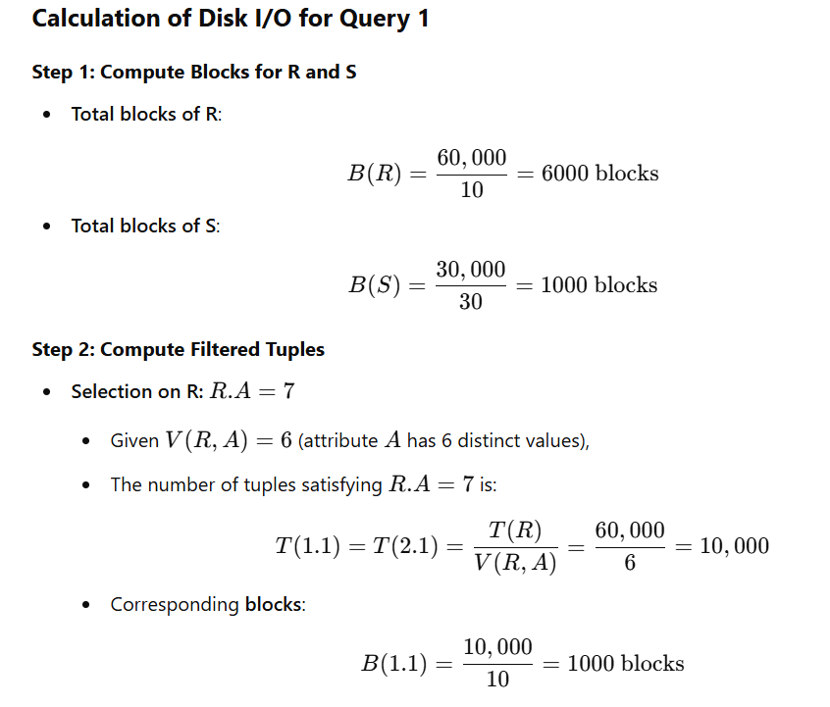

Step 3: Hash Join Execution
- Reading R (filtered on A=7A = 7A=7) → 1000 I/Os
- Creating hash buckets for R → 1000 I/Os
- Reading S → 1000 I/Os
- Creating hash buckets for S → 1000 I/Os
- Writing hash buckets to disk for R → 1000 I/Os
- Reading hash buckets of R in second phase → 1000 I/Os
- Writing hash buckets to disk for S → 1000 I/Os
- Reading hash buckets of S in second phase → 1000 I/Os
Total I/O cost for Query 1 = 11,000 I/Os.

Calculation of Disk I/O for Query 2

Step 1: Compute Filtered Tuples
- Selection on S: S.C=9
  - Given V(S,C)=20 (attribute C has 20 distinct values),
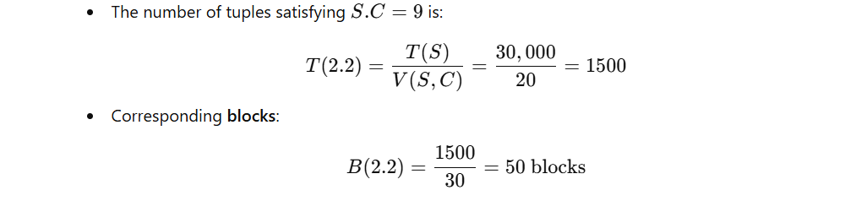

Step 2: Hash Join Execution
- Reading R (filtered on A=7A = 7A=7) → 1000 I/Os
- Creating hash buckets for R → 1000 I/Os
- Reading S (filtered on C=9C = 9C=9) → 50 I/Os
- Creating hash buckets for S → 50 I/Os
- Writing hash buckets to disk for R → 1000 I/Os
- Reading hash buckets of R in second phase → 1000 I/Os
- Writing hash buckets to disk for S → 50 I/Os
- Reading hash buckets of S in second phase → 50 I/Os
Total I/O cost for Query 2 = 9100 I/Os.

Comparison and Insights
- Query 2 is more efficient because it applies two selection filters early. This reduces the size of S significantly (from 1000 blocks to only 50 blocks), minimizing the number of disk I/Os in the hash join.
- The principle of pushing selections early in query optimization helps to reduce intermediate data, leading to significant performance gains.
- The hash join algorithm is efficient when memory is limited, as it avoids costly nested loop operations.

Final Takeaways
- Hash joins are effective for large datasets, especially when no indexing is available.
- Selection operations should be applied as early as possible to minimize the data processed in joins.
- Disk I/O cost is a crucial factor in query execution, and minimizing intermediate results leads to better performance.

